# Department of Computing

# 

**CS-213: Advanced Programing**

**CS 7 B**

# Assignment 1: Exploring open source software

**Date: 07th Sep,2019**

# Instructor: Sidra Sultana

# Image result for drupal

Introduction

Drupal is an open source Content Management System Framework. It has been written mostly in PHP. However, for interface and theming purposes JAVA SCRIPT and AJAX are also used. At least 2.3% of the world websites are powered by drupal.

Drupal provides us with endless possibilities where you can create almost any type of website, ranging from simple blogs to amazing corporate websites. More over a handsome amount of government websites are also powered by Drupal.

Objectives

1. Configure any the open source software (Drupal)
2. Explore it with user perspective.
3. Understand the database and coding structure.
4. Use some online available plugins or modules of respective OSS.

Installation:

The installation procedure is pretty easy and straight forward for a person with average technical skills, though people with little technical knowledge might need some guidance or tutorial to follow, in order to install Drupal error free.

Drupal requires the following pre-requisites:

* A working local server
* A MY-SQL database
* PHP

For my installation I used WAMP server and MySql via PHP myadmin.

**Installation Steps:**

1. Downloading the Drupal zip installer from their official website

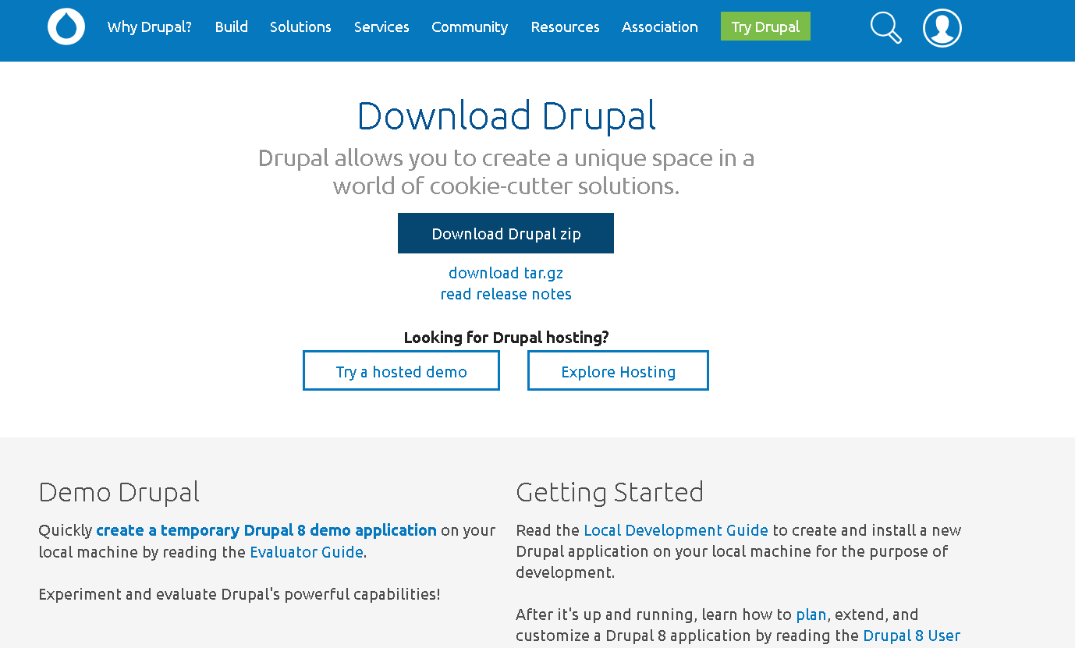

1. Extracting the package in WAMP’S WWW folder

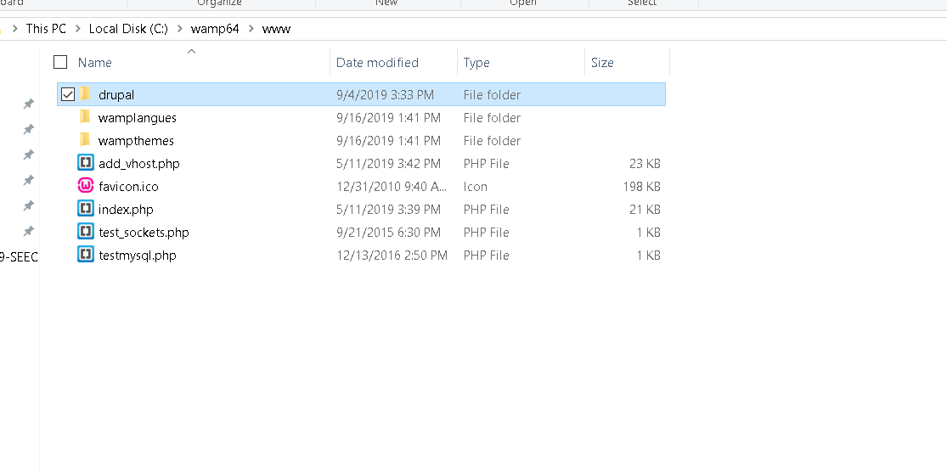

1. Opening the local host and following the instructions shown in screen-shots below

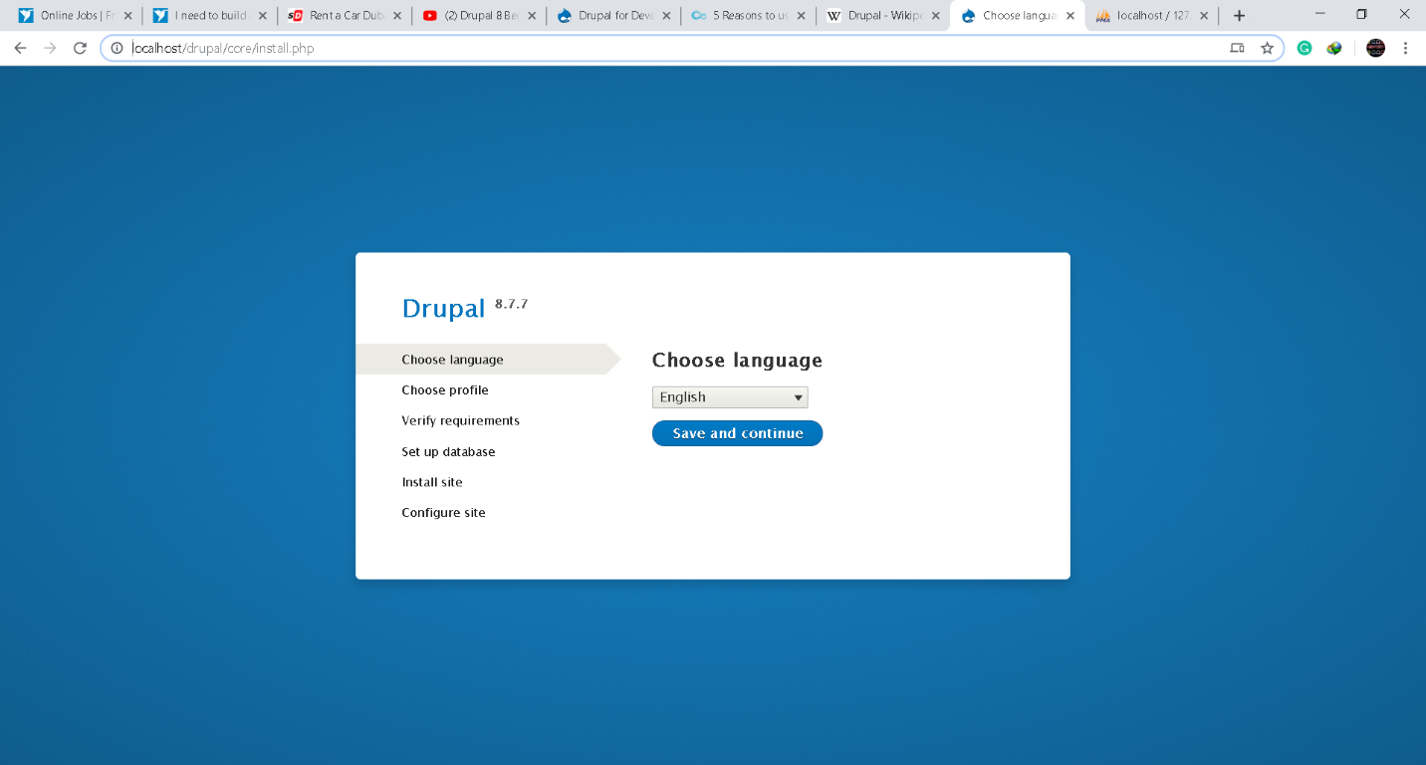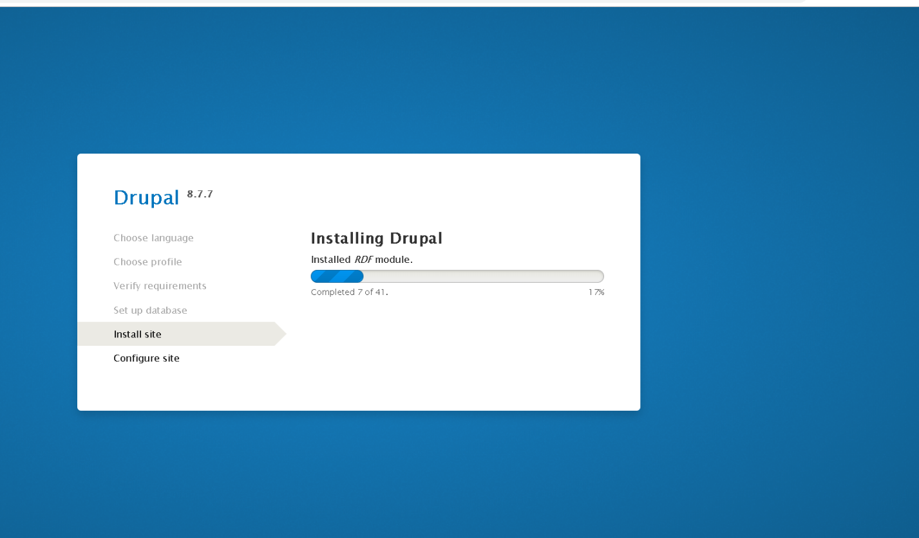

Your data base will also be created as follows

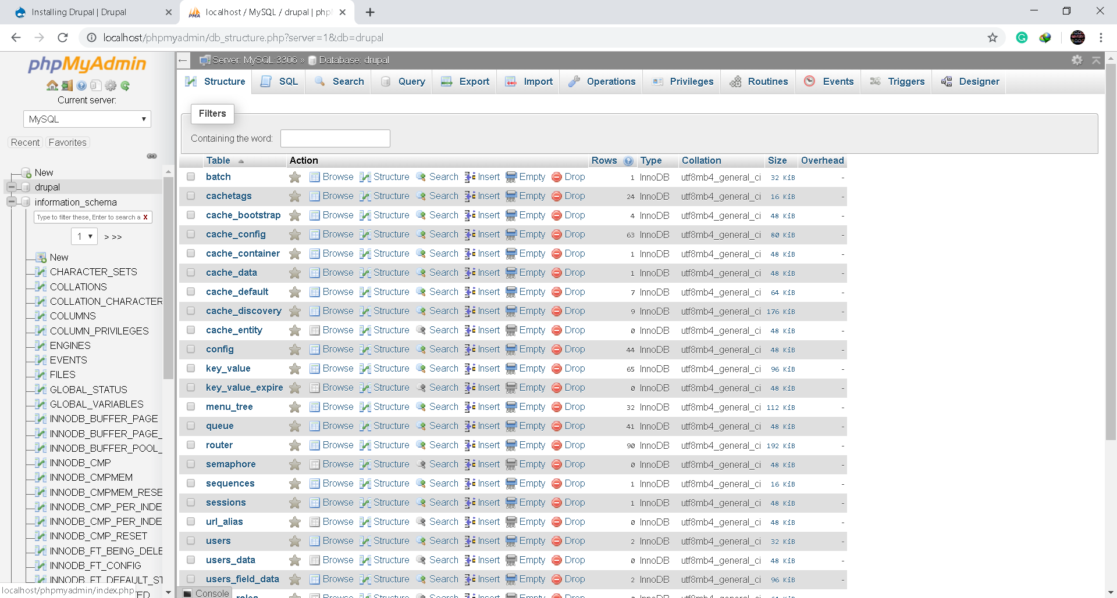

1. After installation you will receive your confirmation and a default drupal homepage will appear in front of you

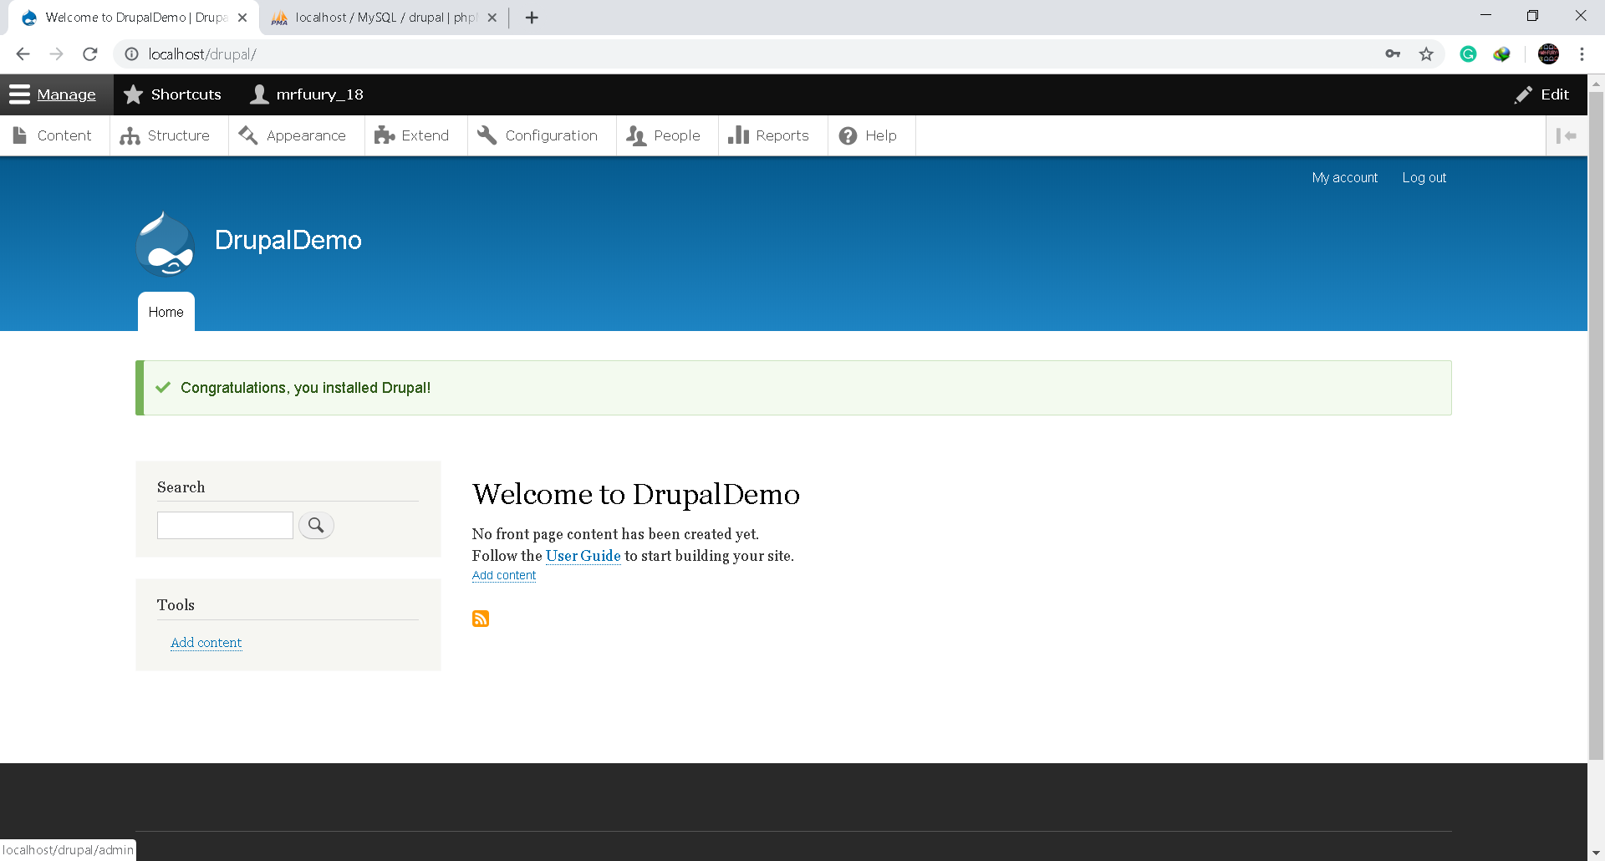

Exploring Drupal:

After setting up Drupal the admin dashboard is the first thing you interact with is admin dashboard, a default front page is presented to the user and which clearly states that the user has not made his landing page of his own

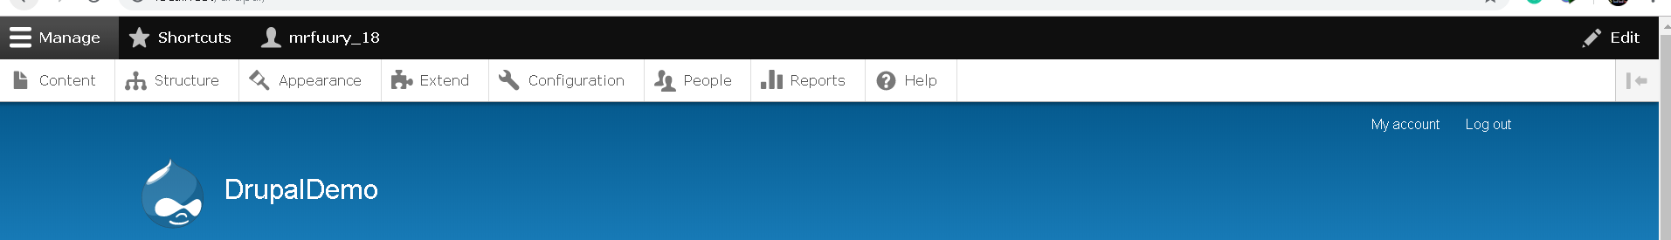

The following menus are provide to the user

* Content
* Structure
* Appearance
* Extend
* Configuration
* People
* Reports
* Help

**Content:**

This menu is used for adding content to your site which can be used to publish static pages as well as articles.

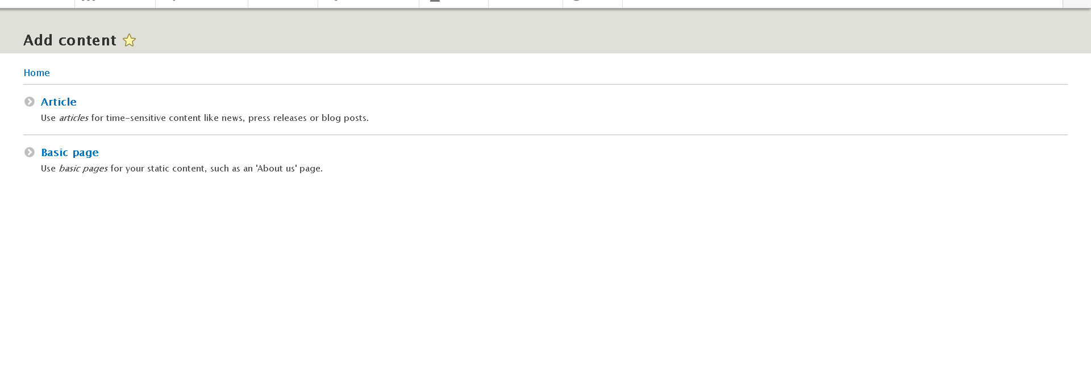

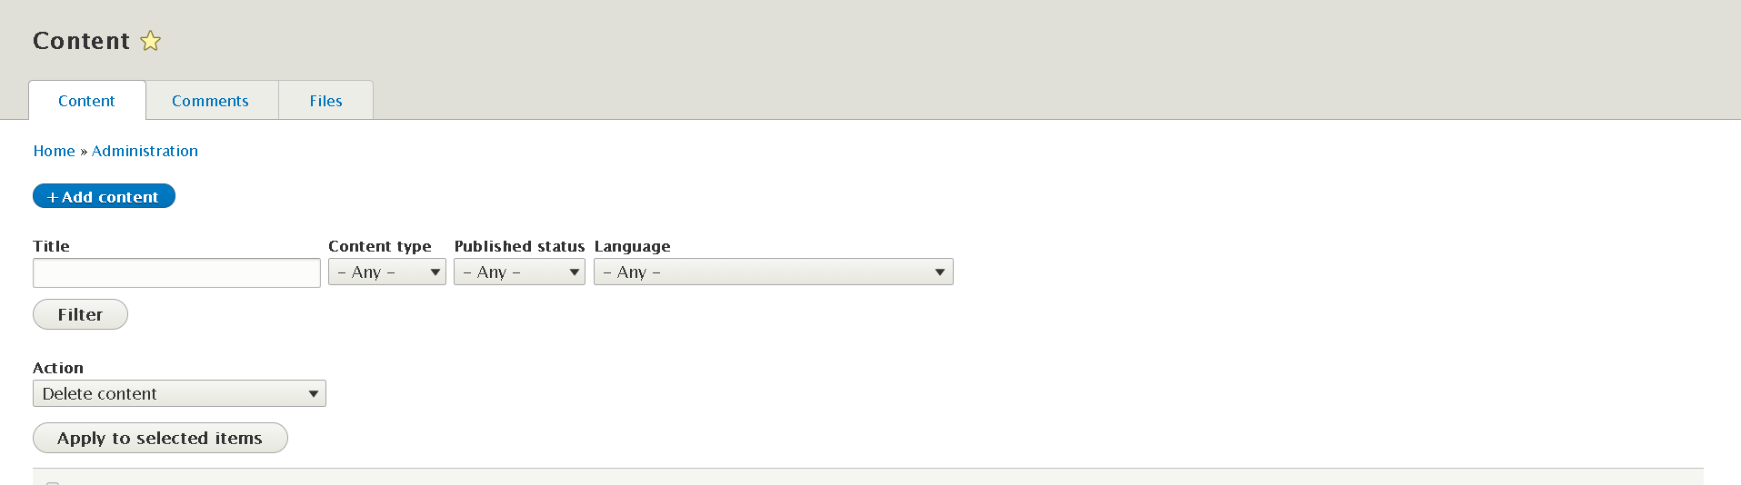

**Article:** 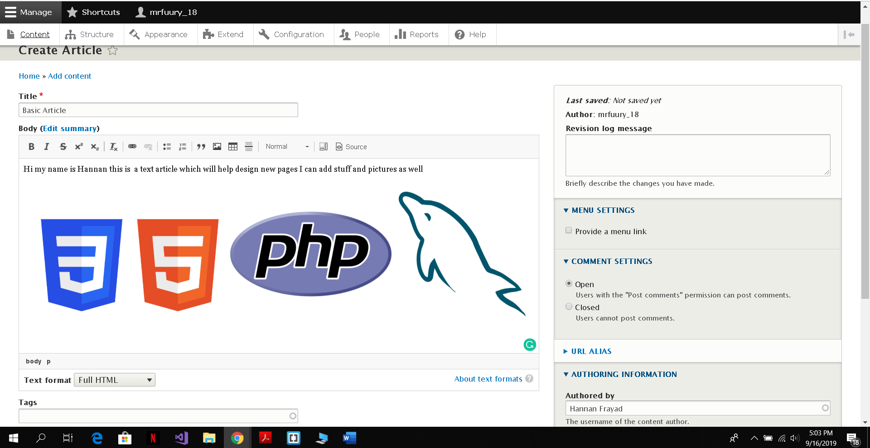

The above screen-shot shows the workspace where you create an article. Space for Title and body is provided where the user can easily input the name of the content and the actual content in the body. The body can be edited in three ways, Full HTML, Basic HTML and restricted HTML.

On the right side you have the option to allow or disallow comments on your articles. Further more the Author’s name and signature can also be changed via the authoring information. A editor might add tags to his article. Once the editor is done with his content, there are two options available, either save and publish the article on his site or load it for a preview (shown below) .

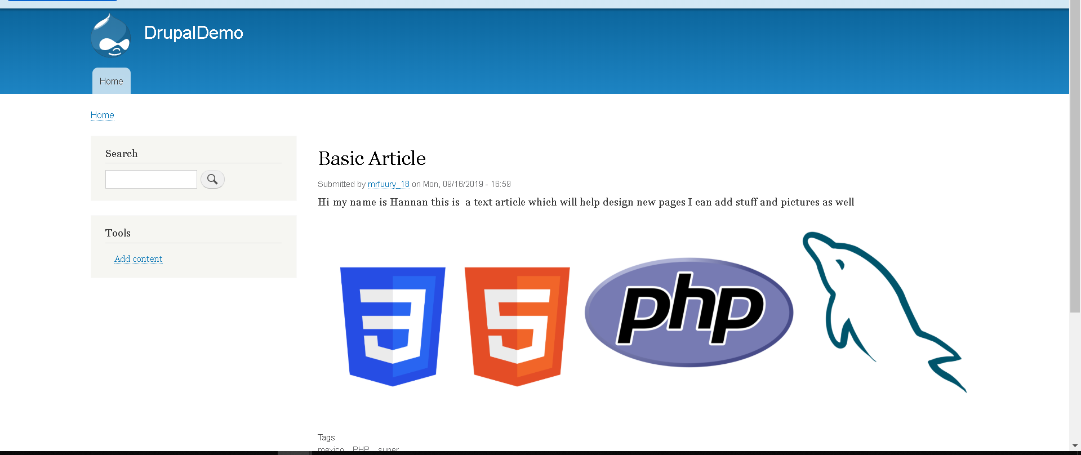

**Basic Page:**

The workspace mechanics and editing space of a basic page is just like your article but it has less editing features, and it is mostly used to create static pages such as About us page. Usually permanent information is stored in a basic page

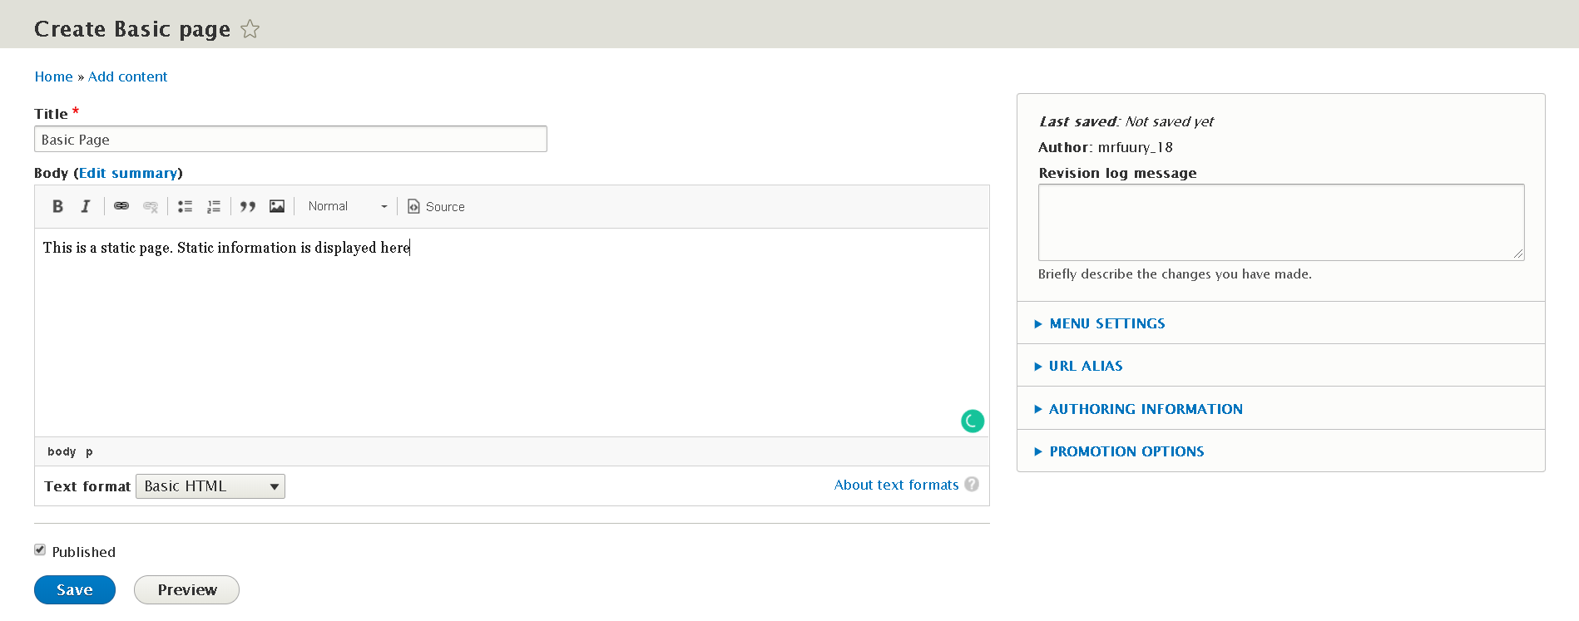

The content tab allows you to view all your published articles and pages along with their title, author, status, and the most recent update time. It also provides you the functionality of filtering content

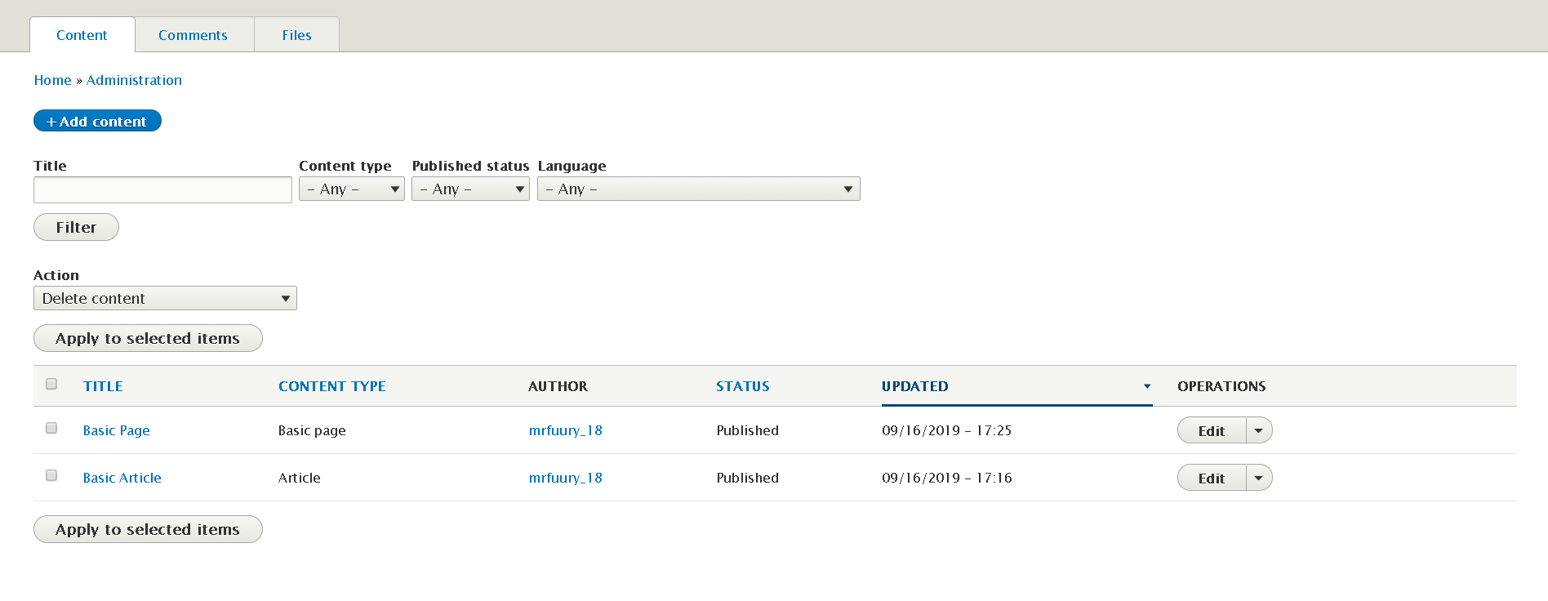

Two options of edit and delete are also provided under the operations tab

**Structure:**

This menu is helpful in defining the structure of the website Which includes the following aspects as shown in the snapshot below

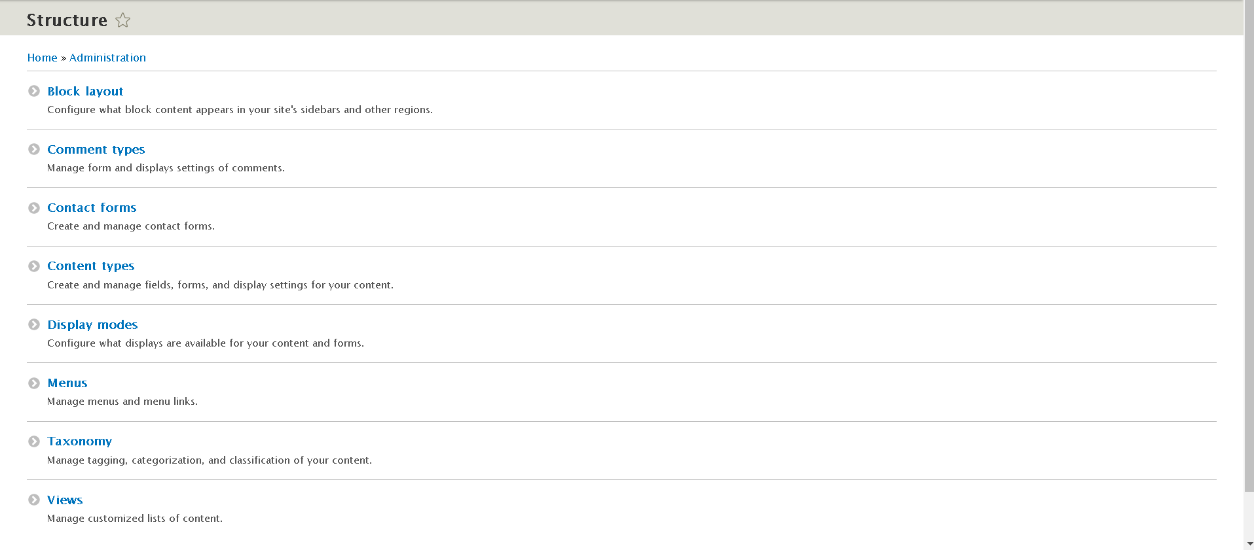

I played around with some of those options and I found them to be quite user friendly and graphically interactive. Visualizing the content right in front of your eyes is a plus point and definitely saves time in terms of website design

In Drupal Structure is managed in terms of blocks. A block can be considered as all objects which appear on your page other than your main content. For Example a header block, a sidebar block, a widget block etc.

Creating a new block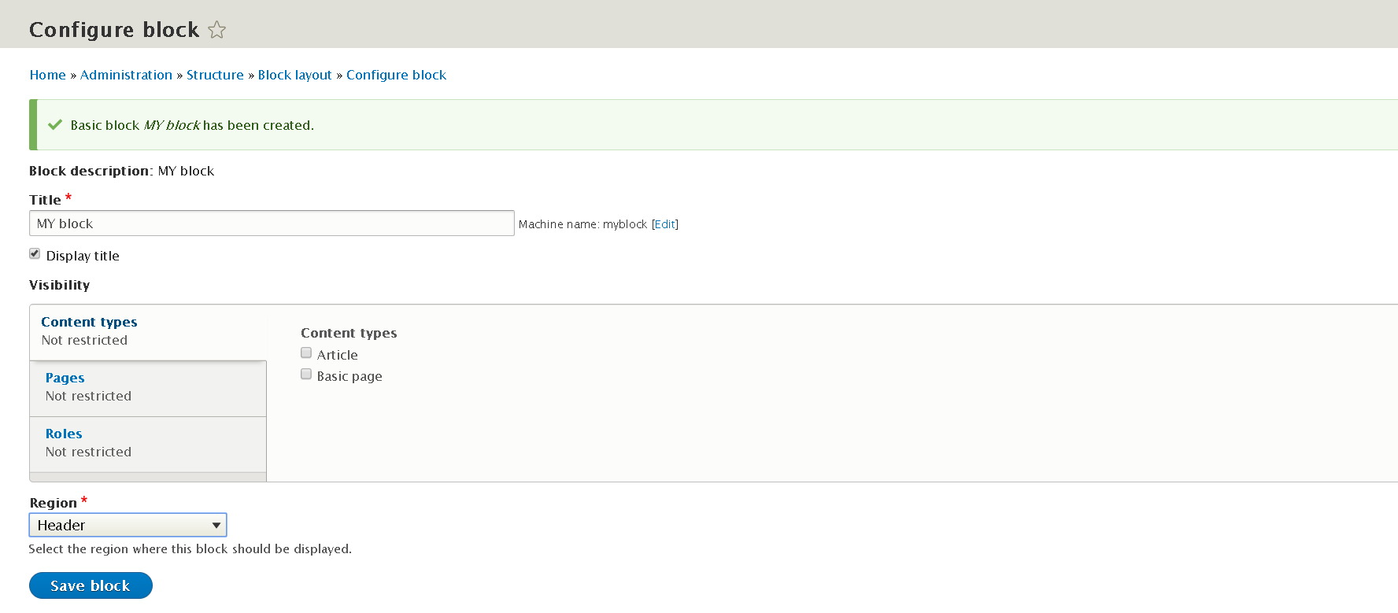

Blocks have two attributes, a category and a region. Two operations configure and delete can be performed on a block

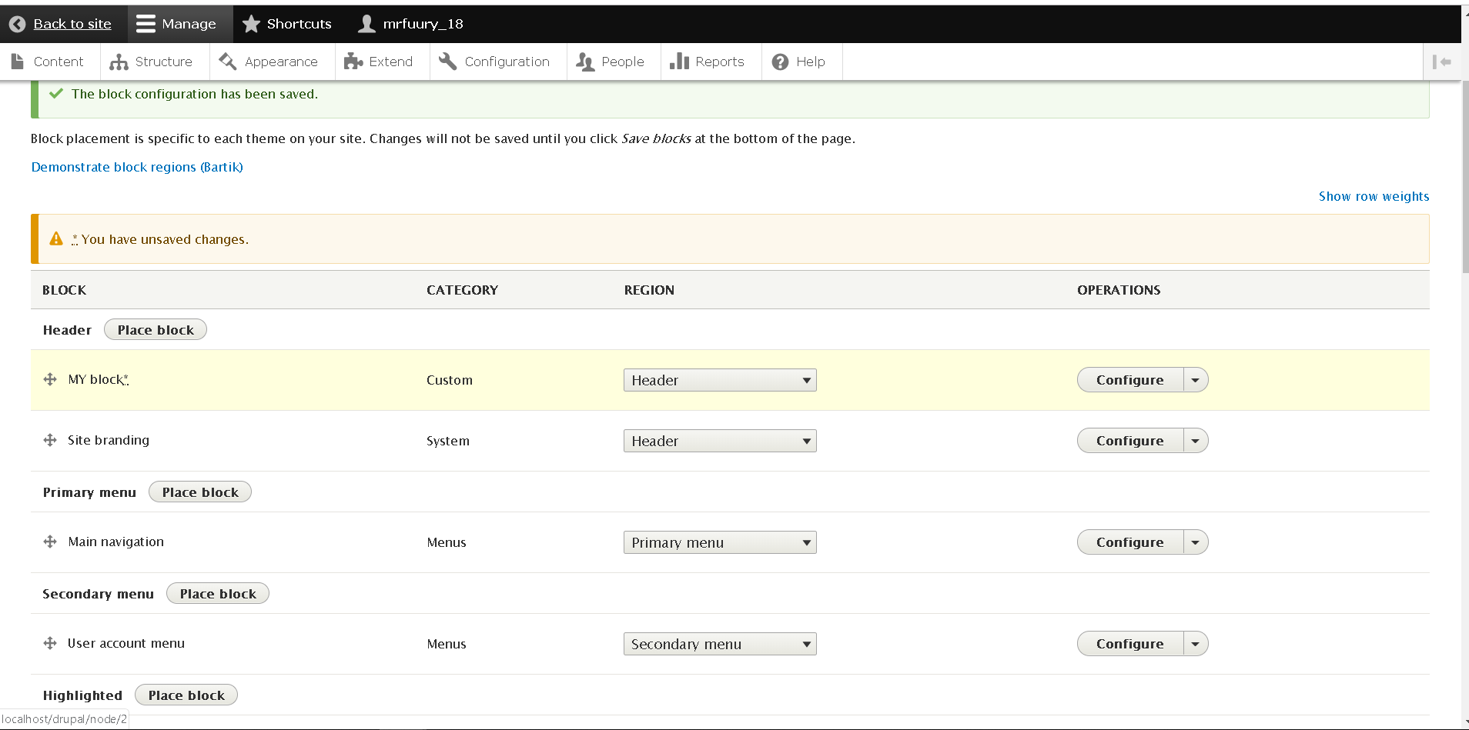



A custom block created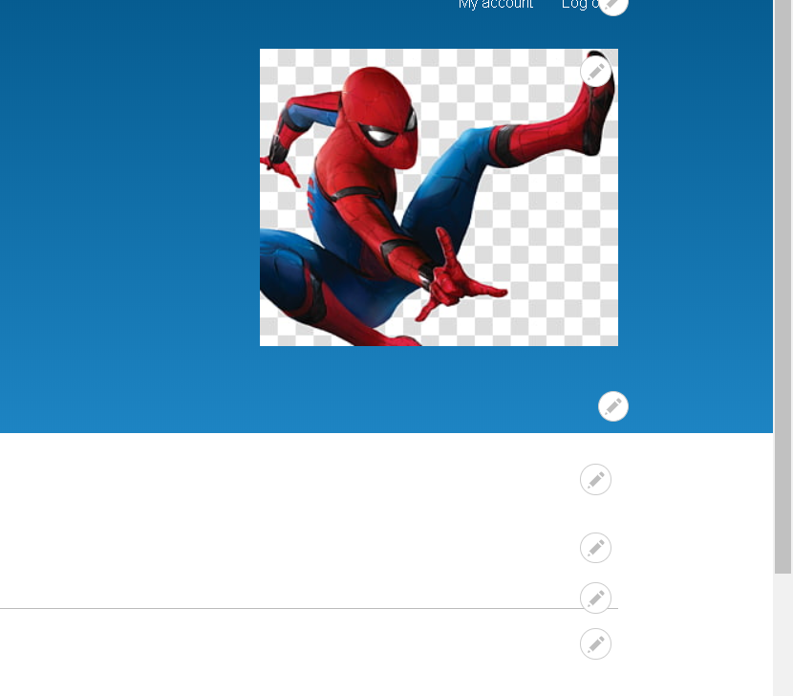

There are also many view modes available for your respective entity I managed to view few of them. Basically they are backend coded and a user is unable to clearly see how they actually work. How a node is shown relies upon the setting wherein it is seen, for example, the contrast between full nodes and mysteries. On the page for field show the executives there are additional settings under the mark custom showcase settings. The settings comprise of a check box rundown of all view modes accessible for nodes, stamping which view modes ought to have tweaked show settings. In a standard Drupal installation just secret is checked, bringing about two sub tabs on the oversee show page – default and mystery. The sub tabs lead to isolate settings for each view mode.

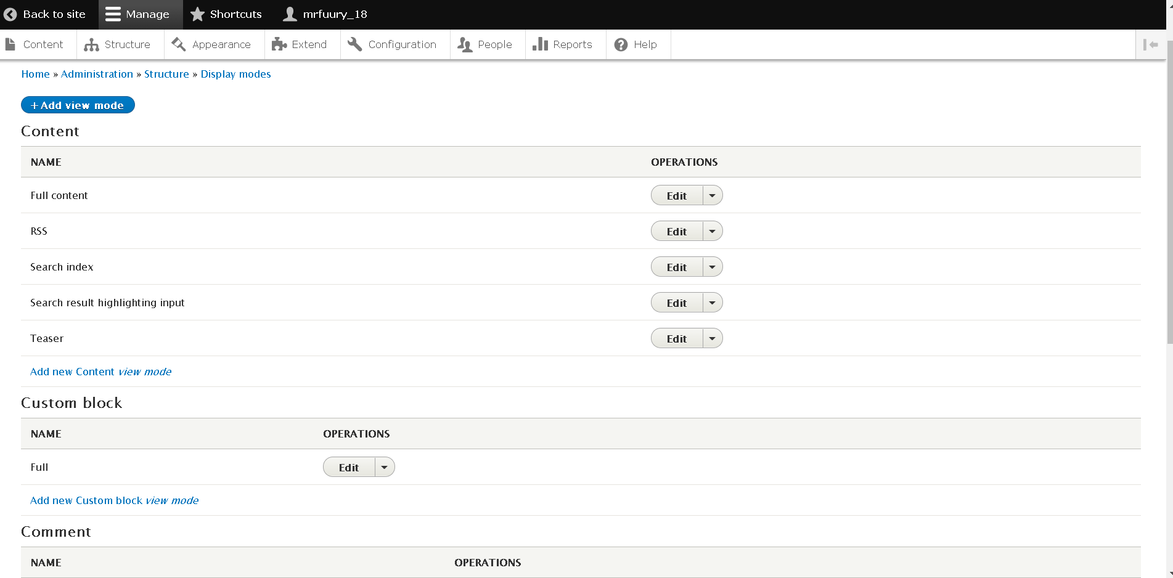

**Appearance:**

Amazingly Drupal provides us with amazing front end customization where we can set a theme, change color schemes, customize logos, add widgets and much more. By default two themes are present in this framework.

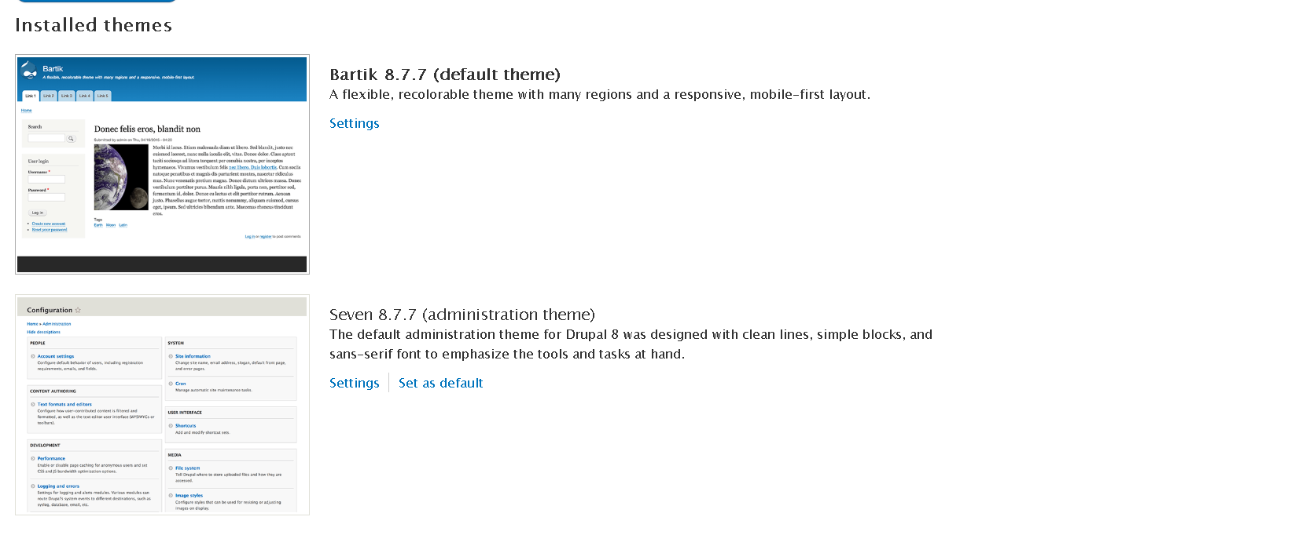

For customizations in themes we have certain options as shown in figure

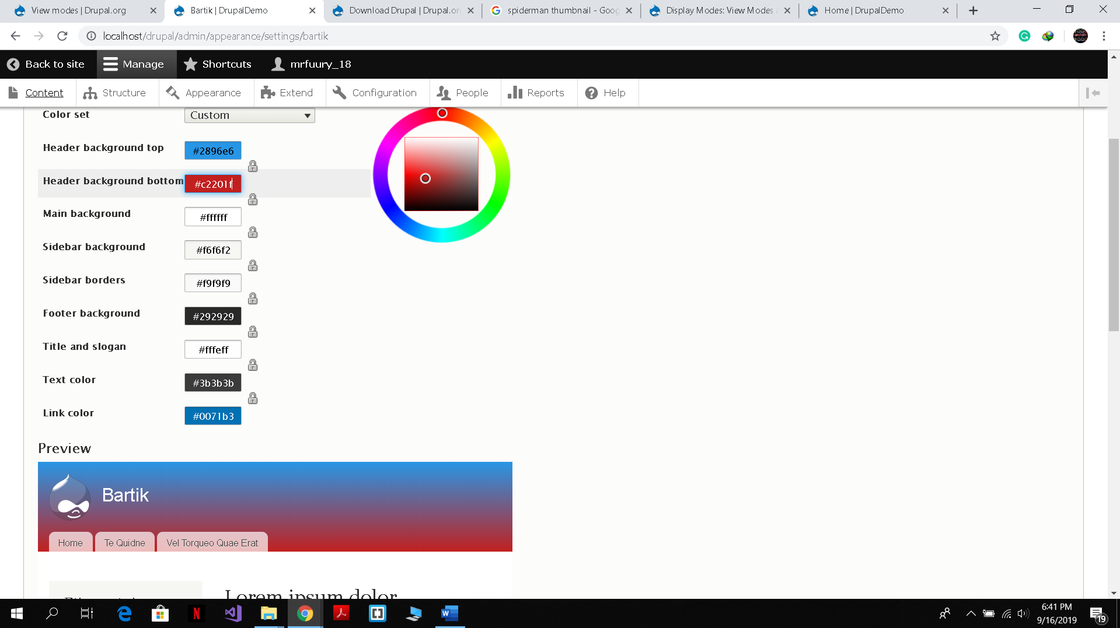

We can also browse and download more themes and even create our own.

**Modules :**

Modules are basically components of Drupal which add extra functionality to our website, for example date time and image modules helps you add date and time to your website and update them accordingly, This allows minimal efforts from the site builders end

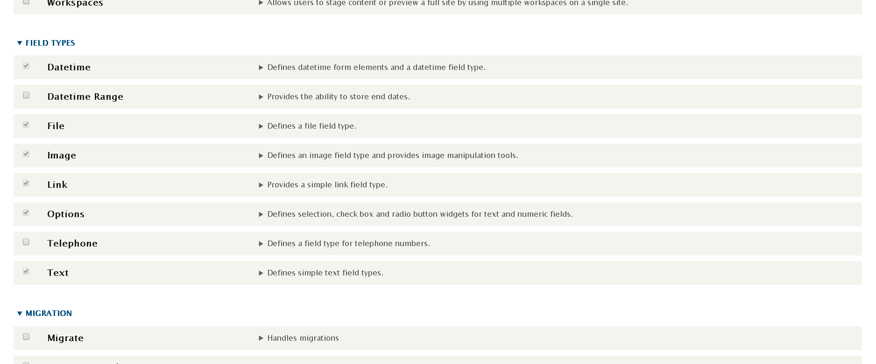

**Configuring and Installing a new module:**

The latest version of Drupal allows us to get modules installed easily without getting into un necessary files

All these modules can be found from the Drupal module repository, which can be accessed from the extend menu in Drupal.

So for demo purposes I installed a new module called path-auto which automatically generates URLs for your pages instead of calling them as nodes

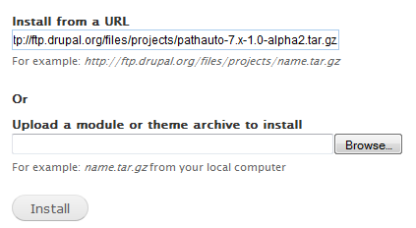

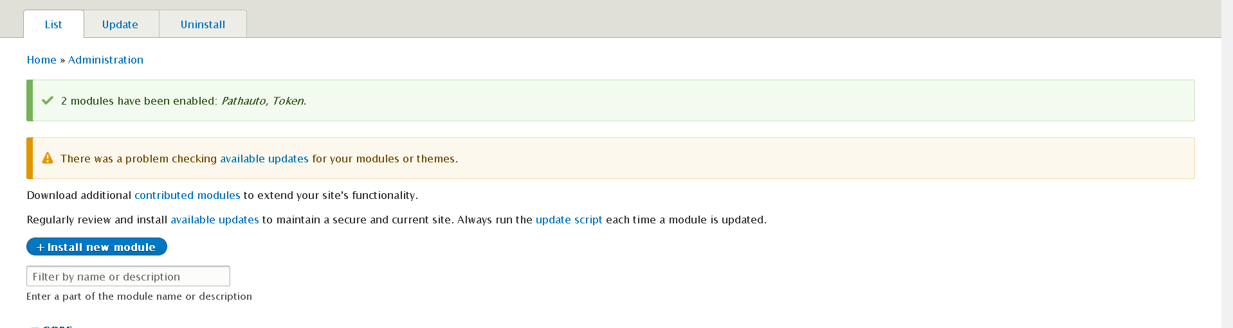

Now using this module instead of calling our Homepage as /node

We will rename it to /home

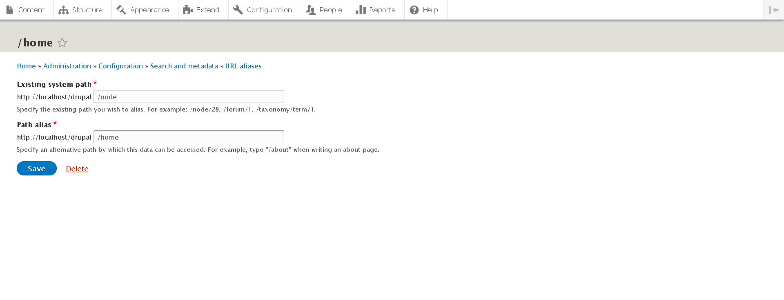

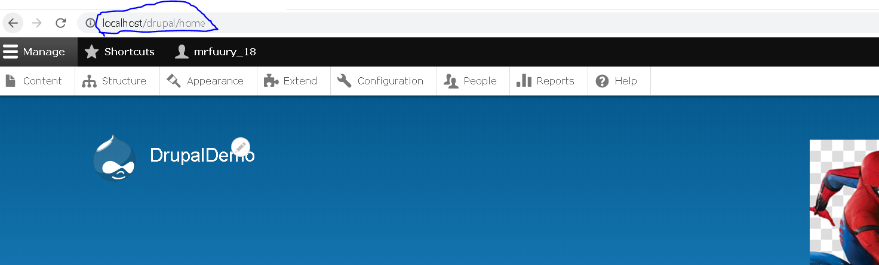

So we see from above screen shots that we can easily assign aliases to our website.

Coding Structures and Data Basis:

As Drupal is open source, its code repository is available on Git hub. Mainly coded in PHP Drupal provides us with extensive features to ease our coding processes

The main coding in PHP uses some AJAX and java script to extract data information and modules

For example the packages.JSon file has all the JS scripts which needs to be executed when required.

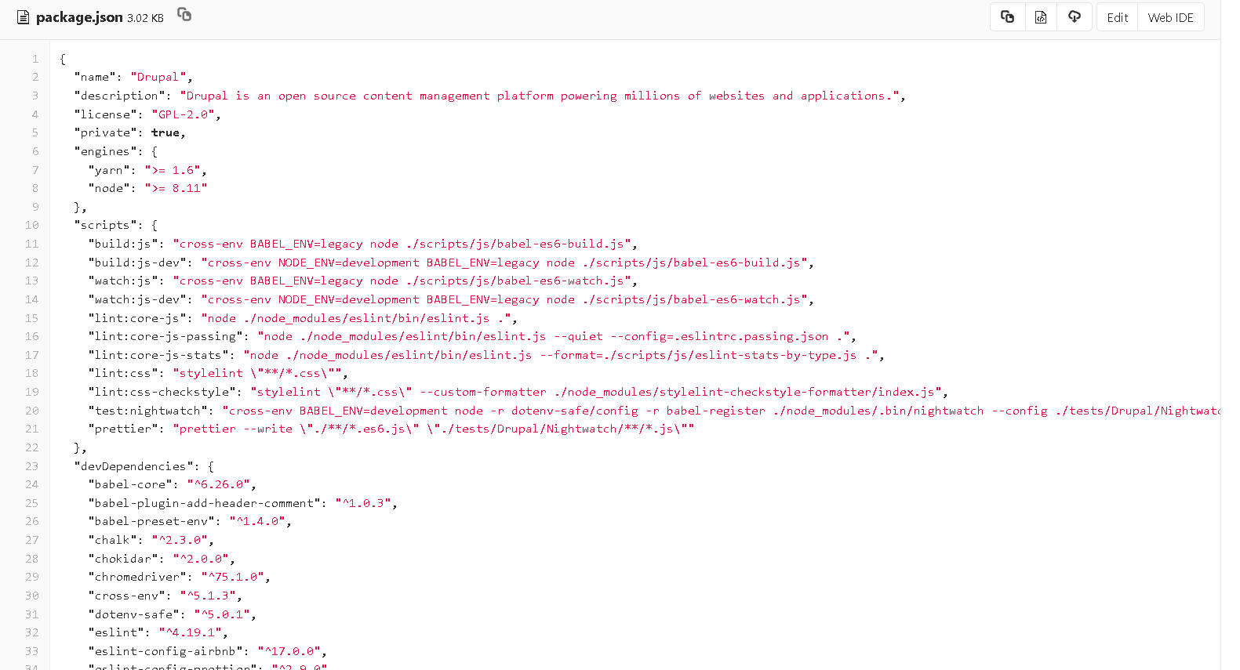

The complete Drupal package has the following layout

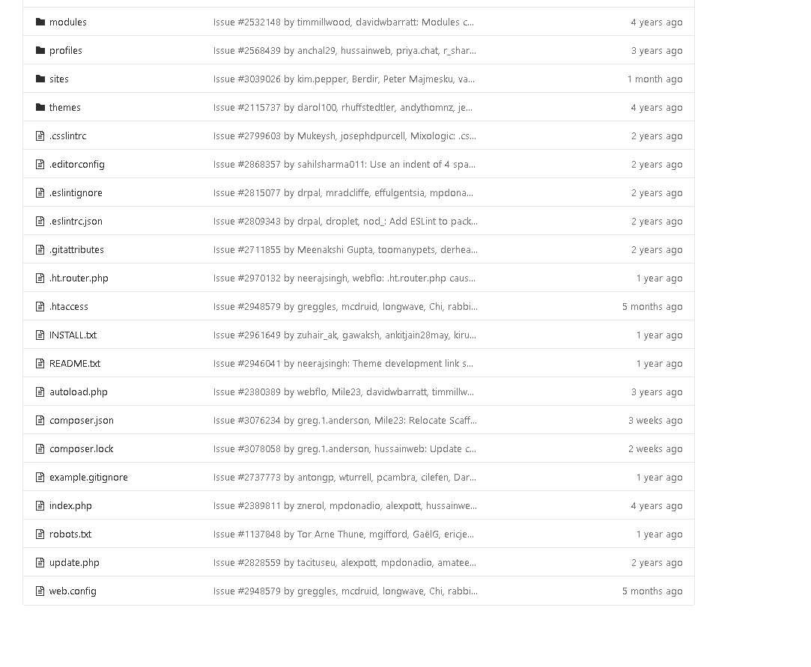

The UML for the Drupal data base is as follows

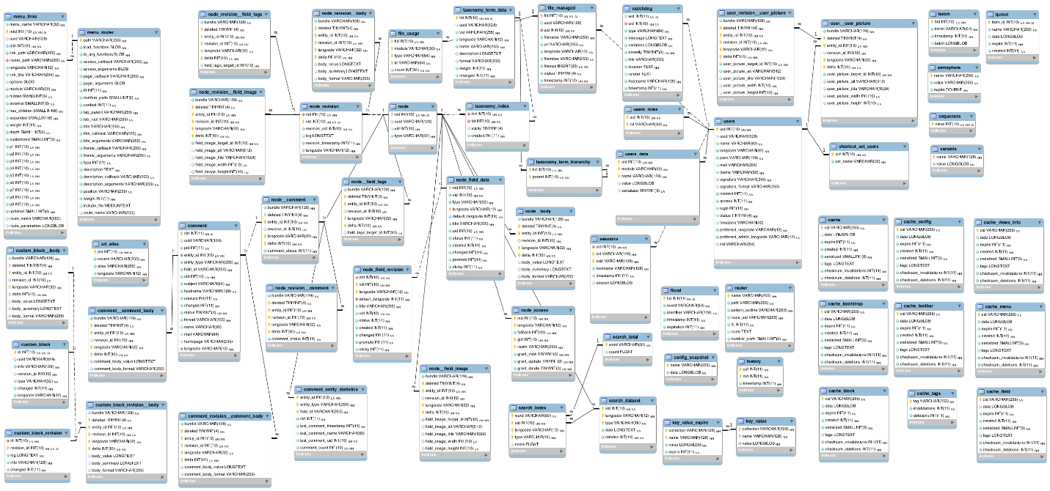

The above UML shows that each component for example comment are given specific ids, This helps in centralized data management and removes the hassle of extensive files

We know that Dupal works in terms of node so a node has its entities, such as node body, node revision, node comments.

There as a main entity user which is further classified into user roles, users data, and a watchdog. We can also see many 1 to 1 and 1 to many relationships